LAI | Literacy Association of Ireland  Cumann Litearthachta na hÉireann
Literacy Association of Ireland’s 43rd International Conference,
Dublin City University (St. Patrick’s campus)
November 8th & 9th 2019

Location: The conference will be held in the E-Block of St Patrick’s Campus (DCU). Please use the library entrance (pictured below) to access the E-Block. This entrance is located next to the Skylon hotel.
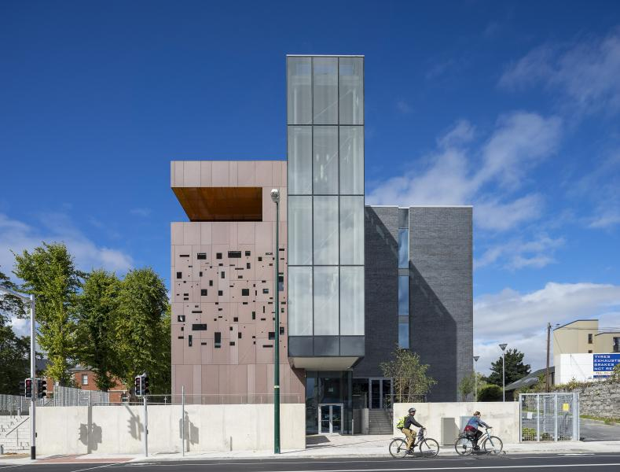

Parking: Parking is available to the right of this entrance and to the rear of the building. Clamping is not in operation after 3.30pm on weekdays or on Saturdays so you will not require a permit to park. Do not park in a ‘park-by-text’ zone unless you have paid on-line. Other parking is free of charge. Several buses coming from the city centre also stop right outside the college. Please see: https://www.dcu.ie/estates/parking.shtml

If you enter via the original entrance (below), you will have to drive around the back of the campus for convenient parking near the E Block. If you enter at reception (near the church), you will need to walk through the A, and C block and follow the stairs to the E Block, taking a left at the top of the stairs. Please see https://www.dcu.ie/info/campus.shtml for a detailed campus map.
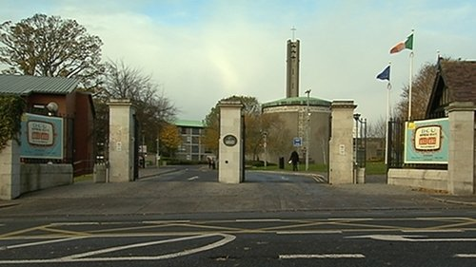

The E Block Atrium is pictured below. This is the location for registration and the keynote sessions are in E223 (highlighted below). The concurrent sessions are located nearby.
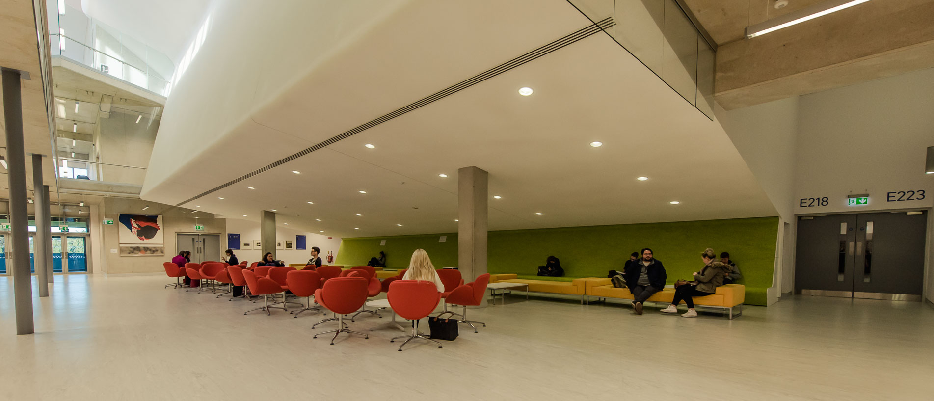

We look forward to welcoming you to our conference!

